Central Baptist Church
Sunday April 7, 2024

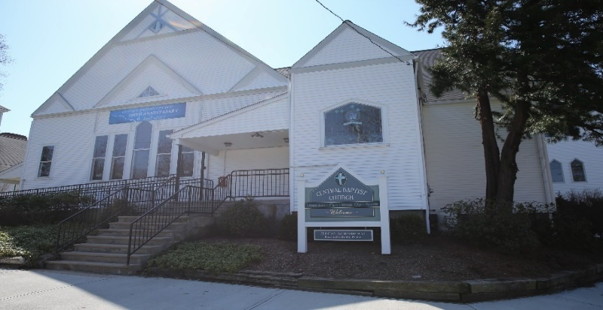

Welcome/Announcements

*Hymn Crown Him with Many Crowns No. 234

Call to Worship
Psalm 133
133:1 How very good and pleasant it is when kindred live together in unity!

133:2 It is like the precious oil on the head, running down upon the beard, on the beard of Aaron, running down over the collar of his robes.
133:3 It is like the dew of Hermon, which falls on the mountains of Zion. For there the LORD ordained his blessing, life forevermore.

Unison Prayer of Invocation
Mighty God, in whom we know the power of redemption, you stand among us in the shadows of our time. As we move through every sorrow and trial of this life, uphold us with knowledge of the final morning when, in the glorious presence of your risen Son, we will share in his resurrection, redeemed and restored to the fullness of life and forever freed to be your people. Amen.

*Gloria Patri No. 623
Glory be the Father and to the Son and to the Holy Ghost, as it was in the beginning, is now and ever shall be, world without end. Amen, Amen.

Communion Hymn Let Us Break Bread Together No. 323

Communion
Invitation to the Table
Sharing of Bread & Cup
Communion Offering for Deacon Missions

Anthem

Children’s Message

Sharing of Joys & Concerns

Pastoral Prayer & The Lord’s Prayer
Our Father, who art in heaven, hallowed be thy name. Thy kingdom come, Thy will be done, on earth as it is in heaven. Give us this day our daily bread. And forgive us our trespasses as we forgive those who trespass against us. And lead us not into temptation but deliver us from evil. For thine is the kingdom, and the power, and the glory, forever. Amen.

Offering & Offertory

Friendship Forms
Please pass the friendship pad in your pew to each person to sign. If you would like to be contacted by someone in the congregation, please leave a note with an e-mail or phone number.

*Doxology No. 625

*Prayer of Thanksgiving
O God, whose richness is not found at the tables of those willing to exchange goods for the sake of acquiring earthly riches, but rather is found at the table of extravagant love for neighbor, we entrust these gifts to your care that they may abound in your steadfast love for all persons. Use them for the building of your beloved community here on earth as it is in heaven. Amen.

Scripture

John 20:19-31

Sermon

*Hymn Breathe on Me Breath of God No. 259

*Benediction

*Postlude

*Please stand if you are able

