Central Baptist Church
Sunday Worship Service
Sunday, April 30, 2023
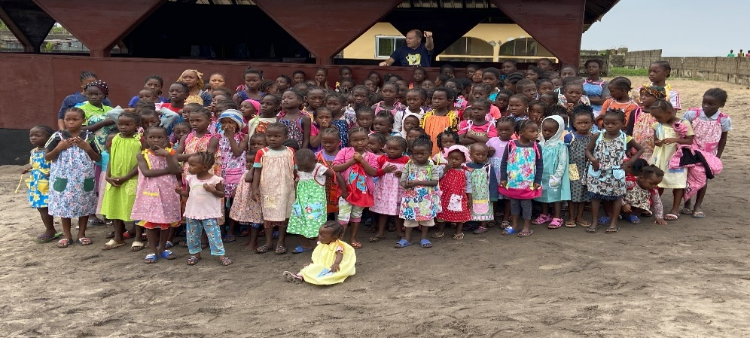
Dear friends, since God so loved us, we also ought to love one another. No one has ever seen God; but if we love one another, God lives in us and his love is made complete in us. ~1 John 4:11-12

Welcome/Announcements

*Hymn All Things Bright and Beautiful No. 578

Call to Worship
One: Let all of God's children come together in the house of the Lord!

All: We are each sisters and brothers in Christ, beloved by Almighty God.

One: The people were bringing their babies to have them blessed by Jesus. The disciples
tried to stop them, but Jesus said, "Let the little children come unto me, and do
not hinder them, for the kingdom of God belongs to such as these."

All: Remind us, Lord, how valuable our children are. We pray that You bless our
children and that we, as parents, teachers, caregivers are a blessing to them.

One: Jesus also said, "Anyone who will not receive the kingdom of God like a little child
will never enter it."

All: May we live with that unpretentious faith. Let our prayers hold a constant
foundation of absolute faith knowing that You always consider our best
interests. May we receive the spontaneous trust of the little ones.
Unison Prayer of Invocation
Lord, You have created us in many varieties, but we are meant to be one in the Spirit, for we are all Your children, young and old alike. Fill us with your Holy Spirit so that we might live together in peace and harmony, in accordance with Your will. We will sing Your praises all the days of our life for mighty are Your works and wondrous is Your creation. We pray in Jesus' name. Amen.

Gloria Patri No. 623
Glory be to the Father and to the Son and to the Holy Ghost, as it was in the beginning, is now and ever shall be, world without end Amen, Amen

Anthem

Jazz Alleluia

Sharing of Joys and Concerns
Pastoral Prayer & The Lord’s Prayer

Our Father, who art in heaven, hallowed be thy name. Thy kingdom come, Thy will be done, on earth as it is in heaven. Give us this day our daily bread. And forgive us our trespasses as we forgive those who trespass against us. And lead us not into temptation but deliver us from evil. For thine is the kingdom, and the power, and the glory, forever. Amen.

Offering & Offertory

Friendship Forms
Please pass the friendship pad in your pew for each person to sign. If you would like to be contacted by the pastor, please leave a note with an e-mail or phone number.

*Doxology No. 625

*Prayer of Dedication

Song Turning Toward the Morning by Gordon Bok
Sung by Judi and Matt Bolles

Scripture
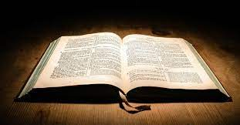
Mark 9:33-37
Mark 10:13-16

Sermon Dialogue: Pastor Kurt and Matsiko converses with the congregation! 😊

*Hymn Jesus Loves Me No. 579

Song The Lord Bless You and Keep You

Benediction (unison)
May the God of endurance and encouragement grant you to live in such harmony with one another, in accord with Christ Jesus, that together you may with one voice glorify the God and Father of our Lord Jesus Christ. ~Romans 15:5–6

The Worship is ended…Our Service Now Begins

*Please stand if you are able

