Central Baptist Church
Sunday, August 7, 2022

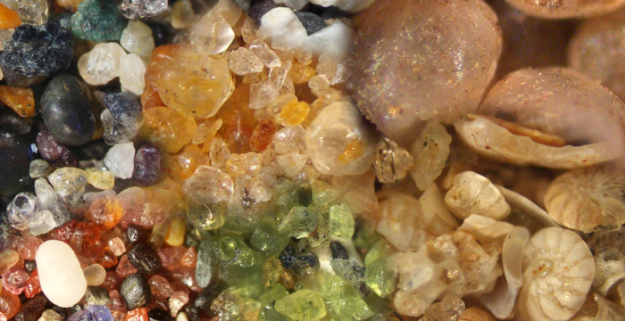

Have I not commanded you? Be strong and courageous. Do not be afraid; do not be discouraged, for the Lord your God will be with you wherever you go.
Joshua 1:9

Welcome/Announcements

*Hymn Morning Has Broken No. 60

Call to Worship
One: God is perfect. God does not make mistakes. God has not made a
mistake in calling you today. You are here. You belong.
All: Perfect Lord and Savior, we rest assured that you will never leave
us.
One: God said, "I will never leave you; I will never abandon you."
All: Let us be bold, then, and say, "The Lord is my helper; I will not be
afraid."
One: Never, ever, forget God loves each of us more than the grains of sand on
this earth.
All: Praise be to God!

Unison Prayer of Invocation
Holy One — our times are in Your hands. We are grateful that You care for us and for all the earth. We do not understand why things are as they are, but we trust that You will never leave us nor forsake us. We are mindful of the intricate ways You bless us and call us to be our best selves. Thank You for your consistent love. Thanks be to you, O God that You are the same yesterday, today, and tomorrow, and that we can depend on Your never-changing constant love revealed to us in Jesus Christ. Amen

Gloria Patri No. 623
Glory be to the Father and to the Son and to the Holy Ghost, as it was in the beginning, is now and ever shall be, world without end Amen, Amen

Joys and Concerns

~Silent Meditation~

Pastoral Prayer & The Lord’s Prayer
Our Father, who art in heaven, hallowed be thy name. Thy kingdom come. Thy will be done, on earth as it is in heaven. Give us this day our daily bread. And forgive us our trespasses, as we forgive those who trespass against us. And lead us not into temptation but deliver us from evil. For thine is the kingdom, and the power, and the glory, forever. Amen.

Offering & Friendship Forms
Please pass the black friendship pad along your pew so that each person may sign. If you would like to set up a visit or meeting with the pastor or know of another who may want a visit, please make a notation on the forms. They are collected by our Deacons each week for the pastor.

*Doxology No. 625
Praise God from whom all blessings flow; Praise Him, all creatures here below; Praise Him above ye heavenly host; Praise Father, Son, and Holy Ghost.

*Prayer of Dedication

SCRIPTURE

Psalm 139:1-18

Message The Sands Of Time

*Hymn May Jesus Christ Be Praised No. 87

Holy Communion

Communion Offering

Benediction

Postlude

The Worship is ended...Our Service Now Begins

*Please stand if you are able

