Central Baptist Church

Greetings from Central Baptist Church:

CBC would like to invite artisans, craftspeople, and vendors to our first Harvest Crafts Fair on November 10, 2018, from 9:00 – 2:00. We are located at 99 Narragansett Avenue in Jamestown at the intersection of Southwest Avenue. We hope you will join us as we are looking forward to holding two fairs a year as a centrally located and beautiful venue.

We will have space for twenty (20) tables with ample room for customers to move about freely. The tables are six feet in length and you are welcome to bring your own table within the six-foot limit for a fee of $100.00/table. We have the availability of four eight (8) foot tables for a fee of $125.00.

All marketing and advertising for this event will be handled by members of the church. CBC will host a bake sale with coffee, tea, and water for customers as they browse the tables. The timing for this event was set for craftspeople to have a pre-holiday venue to sell their wares.

As there are only twenty spaces (we are hoping to open a lower level banquet room for next year), please respond as soon as possible. You will have ample time to set up and take down with more information following to those responding.

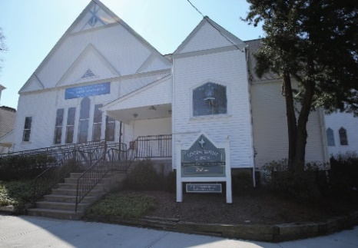

Central Baptist Church

Central Baptist Church Harvest Crafts Fair Application

Artisan/Vendor’s name____________________________________________________

Business Name____________________________________________________________

Address__________________________________________________________________

Email__________________________________ Telephone_________________________

Website (optional)__________________________________________________________

Please make checks out to Central Baptist Church or CBC and mail to:

Central Baptist Church
PO Box 295
99 Narragansett Avenue
Jamestown, RI 02835

Certainly, you may simply drop your checks off at the church office if that is more convenient. Please call the church office with any questions, concerns, etc. at
401-423-1651.

