Central Baptist Church

December 2021

CBC Courier

Pastor’s Pen
Advent is the season of the seed: the seed, Christ said, is the word of God sown in the human heart. ~Caryll Houselander, 'The Reed Of God'.

Advent begins the new church calendar, with a new year of scripture readings, planting God’s seeds (words) in our hearts, imagining new hopes and dreams, and prayerfully a new perspective of God’s blessings for us to enjoy and share in the lives we touch through our kindness and hospitality.

Advent in Latin means “coming”; Jesus ‘coming’ into our lives renewing our spirits. Yet we are not at the stable cradle as Advent allows us four weeks to prepare ourselves to reexamine our relationship once again with our Lord, to open our minds and hearts to be more attentive in our daily walk with Christ. I like to think of Advent as a time of charting out my next adventure or journey with Jesus. A time to contemplate how Jesus will guide me through means I may have neglected in the past through disbelief or doubt. Advent challenges you and me to take those baby steps to what we may once thought impossible, is truly attainable with Christ. As we look back at 2020 with its trials and tribulations as well as triumphs, Advent opens our heart’s window to dream of all the possibilities the future holds.

This can be keenly witnessed with Reverend Phillips Brooks, who began his career teaching. He was not appreciated or respected by his students and grew disheartened eventually terminated from his position. Phillips did not know where his life would take him and was quoted saying he did not care either. Something stirred within Phillips. He became a Christian and went on to become one of the most well-loved, respected preachers of the 19th century. In 1865 Phillips was sent abroad by his parishioners for a year of travel where he spent two weeks in the Holy Land. Phillips was so moved during a Christmas Eve service in Bethlehem, hearing voices of old proclaiming the ‘Wonderful Night’ of our Savior’s birth, upon his return to Philadelphia and Holy Trinity Church he wrote these familiar words we sing each year:

Oh little Town of Bethlehem how still we see thee lie,
Above thy deep and dreamless sleep the silent stars go by,
Yet in thy dark streets shineth the everlasting light,
The hopes and fears of all the years are met in thee tonight.
Reverend Phillips Brooks knew defeat, fears, and yes, hope in God’s grace through a renewing of his heart. This new bright beginning is offered to you, me, and all people as we fill our hearts with Christ’s love during our season of Advent.

May this Advent lead us all to a year filled with health, happiness, and hope!

In Christ’s love,
Pastor Kurt

Communion Sunday & Mission Collection
We will be collecting for the Women’s Resource Center.

Christmas Fair
Saturday, December 4 9:00 a.m.-1:30 p.m.
As our annual Christmas Fair draws closer, here are some ways you may lend a hand:

Here are ways to lend a hand as we prepare for our annual Christmas Fair.

Baked Goodies
We need people to bake for the bake table. A sign-up sheet will be available in the church parlor.

Christmas Craft Table
Donate any handmade craft items like knitted items, ornaments, candles, decorations, etc.

Re-Gift Table
If you have received a gift that is new that you have never opened and used, please consider donating it to our re-gift table.

Fair Volunteers
Plan to work during the fair. We will need as many volunteers as possible—especially volunteers who are able to arrive in time to set up, work throughout the fair, and help with cleanup. We also will need volunteers to help during the week prior to the fair. Sign-up sheets will be available in the church parlor.

Child & Family Services
Due to Covid we will not adopting a family this year. Instead, there will be a collection for gift cards to Walmart that we will then give to Child & Family services for those in need.

Poinsettia Orders
Orders for Christmas poinsettias for our sanctuary are being accepted. The plants will be available in red, white, and pink for $17.00 each. You may designate the poinsettia(s) you order in memory or honor of a person or event. The deadline for orders is Sunday, December 12. Order forms are available in the church parlor or from the church office.
Advent & Christmas Worship Opportunities
Blue Christmas Service
For numerous people, Christmas can be a challenging time with sadness and grief for those who have lost a loved one, struggle with a health or monetary crisis or various other reasons. We will offer a Blue Christmas service on Sunday, December 19th at 11:30 a.m. This quiet service will acknowledge the sense of grief or loss that may come at this time of the year, as well as offer the hope of the Christmas message.

Christmas Eve Service
We will complete our Advent journey during our Christmas Eve candlelight service at 5:30 p.m. on Friday, December 24th. The service will feature carols, scripture, and the congregation’s lighting of the Christ Advent candle.

Brick Patio Fundraiser
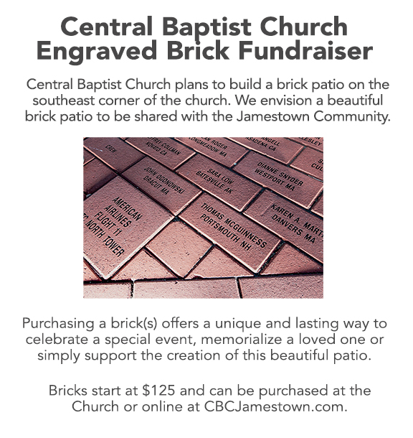

Within our Church Family

Rosemarie Smith has been transferred to a nursing home in NH.
Cards can be sent to her daughter-in-law to bring to her. Any calls should go through the activities director to schedule facetime or zoom.

Sullivan County Nursing Home
5 Nursing Home Drive
Unity, NH 03743
603-542-9511

Send cards to:
Deb Midgett
PO Box212
Springfield, NH 03284

CBC Walking Work-Out
Free and friendly! No gym membership fees required! Walk with us to up-beat music on Tuesdays and Thursdays from 8:00 a.m. to 8:45 a.m. We start with a gentle warm-up, walk about two miles, then cool down, followed by gentle stretches. This full-body workout is non-competitive and can be done at your own level/pace. Wear comfortable clothes and whatever shoes you like for walking, as well as a water bottle. We meet in CBC’s Clarke Hall for a well-lit, non-slip, and even flooring location. Questions????
Contact Ellen Greene.

We Noticed Some Nice Things Happening at CBC
If you see someone “doing something nice for CBC or to Thank someone". Please call the church office 423-1651 or by e-mail to tanya@cbcjamestown.com your input is always appreciated…Thanks!!

The person or persons who made the church look lovely with holiday decorations inside and outside of church!!

Many thanks again to all!!!

Poinsettia Order Form

Name(s) _____________________________________ Phone ____________________

The poinsettias will be provided by The Secret Garden. They will be available in red, white, and pink and will cost $17.00 per plant. Please make checks payable to Central Baptist Church. (Payment must be included with this order form.)

Include in the Christmas insert as:

(Choose one) ___ In memory of or ___ In honor of

________________________________________________________

Given by ________________________________________________________

Color ___ Red ___ White ___ Pink

The deadline for ordering poinsettias is Sunday, December 12.
Please place your order form and payment in the box in the parlor, or mail them to the church office at P.O. Box 295, Jamestown, RI 02835-0295.

--------------------------------------------------------------------------------------------

Central Baptist Church
A church with open doors A congregation with open minds A community with open hearts
99 Narragansett Avenue
(Mail: P.O. Box 295)
Jamestown, RI 02835
(401) 423-1651
cbc@cbcjamestown.com
www.cbcjamestown.com

Pastor Administrative Assistant Organist & Choir Director Custodians
Kurt Satherlie Tanya Crowley Walter Sage John & Jim Page

