Central Baptist Church
Sunday, December 4, 2022

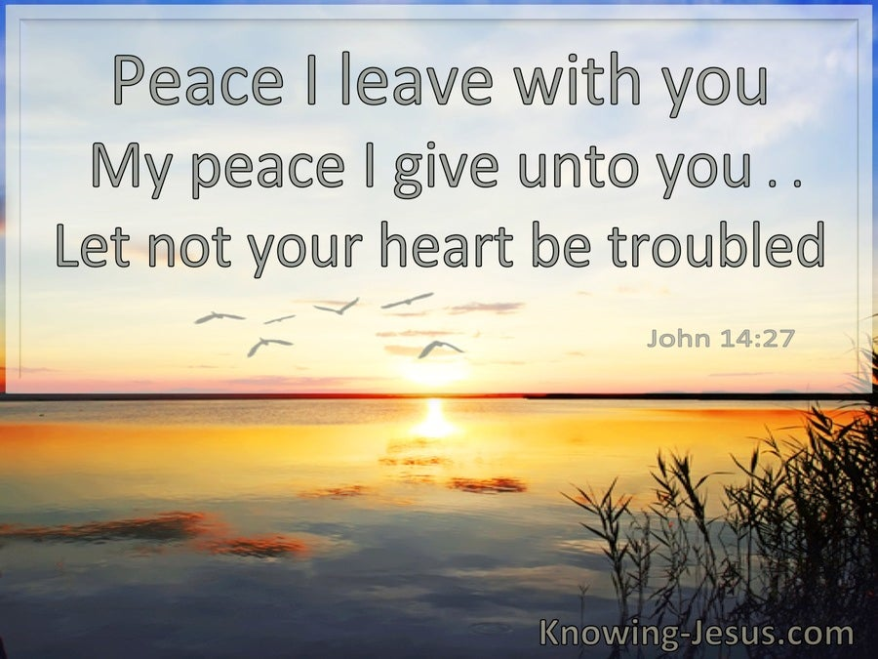

While you are proclaiming peace with your lips, be careful to
have it even more fully in your heart. ~Saint Francis of Assisi

Prelude

Welcome/Announcements

*Hymn O Come, All Ye Faithful No. 145

Call to Worship
One: May our hearts be filled with thankfulness for God’s generous Spirit.
All: Hear our songs and prayers of thanksgiving as You show us
the way of peace.
One: Surround yourselves in God’s Word discovering the peace only Christ
provides.
All: And we will know a peace that we had not expected. Come,
let us worship God.

Unison Prayer of Invocation
Lord God, we pray for peace in our world and in our lives. You give us peace with You through our Savior, Jesus Christ. People long for peace and cry out for a day when war and strife will be no more. Offer us the vision of standing in Your presence, at peace with all those around us, and at peace with You, our God. Thank You Holy One for the peace that passes our understanding yet not our hearts!

Gloria Patri No. 623
Glory be to the Father and to the Son and to the Holy Ghost, as it was in the beginning, is now and ever shall be, world without end Amen, Amen

Lighting of the Advent Candle {Choir Intro} Jill and Dave Dolce

Holy Communion

Communion Offering for Deacon Missions (not for the regular Sunday offering of pledges)

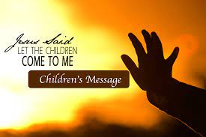

(Children are now excused for Sunday School)

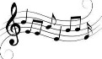

Anthem
Light a Candle for Peace

Joys and Concerns

~Silent Meditation~

Pastoral Prayer & The Lord’s Prayer
Our Father, who art in heaven, hallowed be thy name. Thy kingdom come. Thy will be done, on earth as it is in heaven. Give us this day our daily bread. And forgive us our trespasses, as we forgive those who trespass against us. And lead us not into temptation but deliver us from evil. For thine is the kingdom, and the power, and the glory, forever. Amen.

Offering & Friendship Forms
Please pass the black friendship pad along your pew so that each person may sign. If you would like contact from the pastor, please leave a note in the remark section

*Doxology No. 625 Praise God from whom all blessings flow; Praise Him, all creatures here below;
Praise Him above ye heavenly host; Praise Father, Son, and Holy Ghost.

*Prayer of Dedication

SCRIPTURE

Philippians 4:4-9; John 14:15-27

Sermon Jesus’ Promise of Peace

*Hymn Lord, Let Us Now Depart in Peace No. 609

Benediction

Postlude

The Worship is ended...Our Service Now Begin

*Please stand if you are able

