Central Baptist Church
Sunday, May 14, 2023

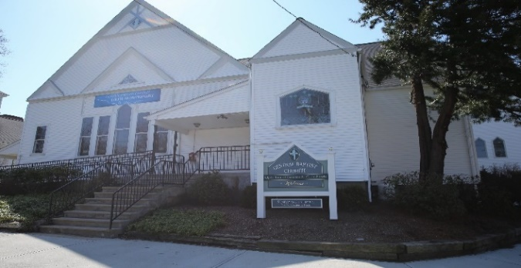

”Sometimes, it takes only one act of kindness and caring to change
a person's life.”-- Jackie Chan

Welcome/Announcements

*Hymn I Sing the Mighty Power of God No. 59

Call to Worship
One: Temptation surrounds us at every turn, inviting us to take just a little
more:
All: More food, more money, more power, more life!

One: “What could it hurt?” we hear, on television, from friends, in our own
souls.

All: More suffering, more hunger, more need, more fear, more anger.

One: So we gather today in worship to hear the consequences of “more.”

All: And to celebrate that we do not need “more” when we have everything in
Christ.

One: Beloved of God, let us drink deeply from the wellspring of God’s Spirit,
which has all we need to live fully, love deeply, and serve faithfully.

All: Thanks be to God!

Unison Prayer of Invocation
We gather to worship, O God, under the shadow of the Cross, sign of human suffering and divine wisdom. Like Jesus, we would follow faithfully in your way; like Jesus, we would live to You and die to You.

Gloria Patri No. 623
Glory be the Father and to the Son and to the Holy Ghost, as it was in the beginning, is now and ever shall be, world without end. Amen, Amen.

Anthem Peace Like a River/Amazing Grace
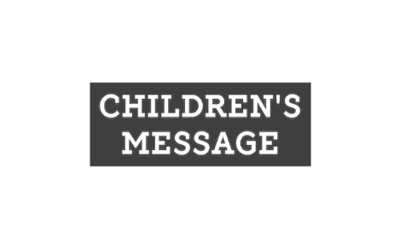
Sharing of Joys & Concerns

Pastoral Prayer & The Lord’s Prayer
Our Father, who art in heaven, hallowed be thy name. Thy kingdom come, Thy will be done, on earth as it is in heaven. Give us this day our daily bread. And forgive us our trespasses as we forgive those who trespass against us. And lead us not into temptation but deliver us from evil. For thine is the kingdom, and the power, and the glory, forever. Amen.

Offering & Offertory

Friendship Forms
Please pass the friendship pad in your pew to each person to sign. If you would like to be contacted by someone in the congregation, please leave a note with an e-mail or phone number.

*Doxology No. 625

*Prayer of Dedication (unison)
Gracious God, we recognize that giving is one of the ways we practice our faith. It enlarges our hearts and encourages our hands and feet to do God’s work in the world. It also builds a sense of community as we combine our gifts for the good of others. We offer these gifts and this prayer in Jesus’ name we pray. Amen.

Scripture

Matthew 25: 31-40

Sermon Just as You Did the Least of These

*Hymn The Old Rugged Cross No. 292

Benediction

Postlude

The Worship is ended…Our Service Now Begins

*Please stand if you are able

