Central Baptist Church

May 2018

CBC Courier

Pastor’s Pen
Keep on loving one another as brothers and sisters. Do not forget to show hospitality to strangers, for by so doing some people have shown hospitality to angels without knowing it. ~Hebrews 13:1,2

Dear CBC Family,

This is one of my favorite scripture verses in the Bible. It is a simple reminder to show hospitality to everyone we meet. Who knows, the person you meet may have entertained angels themselves. With any person we meet, if we treat them as if we were greeting Jesus, just imagine how our greetings and overall attitude and outlook on this worldly life would blossom.

On Sunday I preached about the decline of many mainline churches across the nation as well as churches on the mend and considered thriving. It was the beginning of what I hope to be an ongoing dialogue with our church. Morna Bucklin sent me a book called, “Christianity For the Rest of Us” by Diana Butler Bass. Taking it along on my recent vacation, I am hoping to have our congregation read it as Bass leads the reader on a three-year research journey revealing ten churches across our nation (of all sizes and denominations) that are thriving. There are different reasons within the churches for this blossoming however one theme came across loud and clear. A common denominator for these thriving congregations (some of which were on the verge of closing) was hospitality shown among the parishioners and extending to all visitors. We do this quite well! However there is much more.

Identifying through dialogue the church’s traditions, core beliefs, missions and existing ethos is the first step toward creating a healthy culture. Each member can voice what they feel and observe are positive attributes inside and beyond the doors of CBC. Our discussions will enable all to propose what we do well and those items that need pruning, nourishing, updating, changing, etc. The culmination of our strategic planning will optimistically place everyone on the same sheet of music. Over time with new members joining and some longtime members leaving, the underlying culture can become blurred or lost.

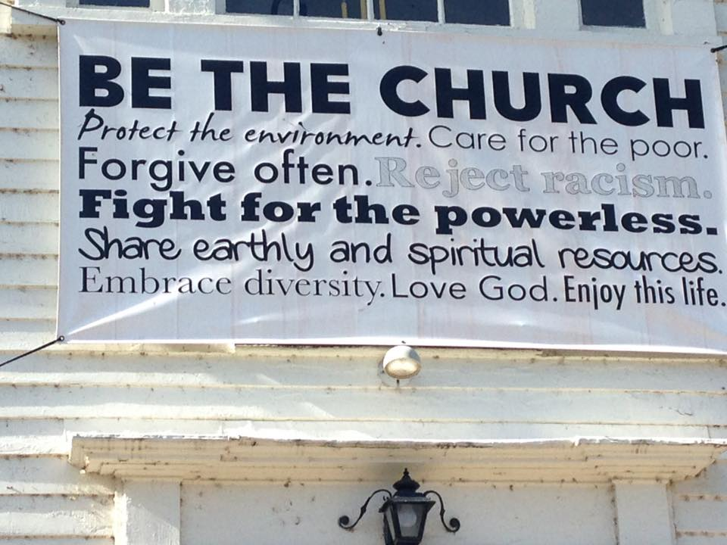
My proposal is to identify our member’s core values for CBC, exploring if they hold true now to all parishioners and where we want CBC to be in the near future and years from now. Our conversations could discover we do not need to change anything to realizing life-changing relationships with God, with each other, and with the world around us. It’s up to each one of us with equal voices.

In the interim, it would be wonderful to see a message for passersby like this one a friend sent from a church in CT. Any ideas for a ‘like’ banner?

In Christ’s Love,
Pastor Kurt

____________________________________________________________

Communion Sunday Collection
On Sunday, May 6th For our communion collection we will be collecting food items for our local area food bank. We are looking for things like peanut butter, canned goods, Pasta & pasta sauce and any non-perishable box items, such as cereal and crackers.

Essential Oils Educational Class
Want to learn about Essential Oils and where they come from. Join us in learning how they work along with the various ways to incorporate them into your lifestyle. From household cleaning, to mood enhancement, pain management and overall well-being. Please join us on May 6th at 11 a.m. in Clarke Hall.

Ladies’ Breakfast
Ladies Breakfast will be held on Thursday, May 17th at 9 a.m. at Slice of Heaven. All CBC ladies welcome!

CBC Annual Meeting
Our annual meeting will be held on Sunday, May 20th at 11 a.m. in Clarke hall. Join us to hear reports about our congregation’s work during the past year, elect leaders for the new year, and consider our annual church budget.
June Festival Committee
Please notify Jill Dolce of your interest in serving on the June Festival Committee so an initial planning meeting can be scheduled. Contact Jill at j.dolce@cox.net or 842-9661.

June Festival
Saturday, June 16 9:00 a.m.-1:30 p.m.

CBC’s largest fundraising event of the year is just around the corner. Here are some ways you can help.

Volunteer
Volunteer to work at the festival by signing up on the poster in Clarke Hall. Recruit others to work with you.
Donate Items
Begin to clear out your clutter and encourage neighbors and friends to do the same. We hope to receive donations of the following items for the sale:
gently used household & garden items toys & games
small wood & wicker furniture marine & boating items
jewelry & vintage items sporting & fishing items
artwork & decorative items small rugs & appliances

(We are unable to accept televisions, computers, upholstered furniture, large appliances, or entertainment centers.)
If you need help transporting items to the church, please call David Dolce at 374-2858.
Spread the Word
Post Clear Out the Clutter flyers in the community. (Copies are available in the church parlor.) Spread the word about our Saturday morning (9:00 a.m.-noon) donation drop-off dates: May 26, June 2, and June 9.
Get Silent Auction Items
Ask stores, salons, restaurants, and other businesses you frequent for items or gift certificates for the silent auction. A letter is available for you to present when you request an item. Also consider donating never-opened/never-returned gift items you may have.
Bake Goodies
Bake and freeze your favorite goodies for the bake sale.
Potted Plants
Pot thinned plants from your garden, and save them for the garden center.

Little Dresses for Africa
The mission of “Little Dresses for Africa” is to provide relief to children of Africa, by distributing home-made dresses to little girls, primarily in African villages, but also other countries in crisis. These meetings will be on the 1st and 3rd Monday of the month from 1:00-3:00 p.m. in Clarke Hall.

Living with Conscious Abandon
Will meet on the 4th Monday of each month at CBC in Clarke Hall from 1 - 2:30 pm. The group focuses on personal reflection of both Christian and Eastern Spiritual guidelines in living each day with conscious awareness of personal intention, thought, speech and actions. Join us as we gather to share our responses to daily reflections that will support us in living our lives with wisdom, integrity and compassion. Our reference guide is Living and Dying with Confidence: A day by day guide by Anyen Rinpoche and Allison Choying Zangmo. The text may be purchased at Amazon for $11.We will begin with month 5 in October. All are welcome. The class is free of charge. Rev. Kurt Satherlie and Janet Larson facilitate the sessions. Mark your calendar for this seasons' sessions: May TBA.

CBC Walking Party
Please join us as we walk to up-beat music in Clarke Hall on Tuesdays and Thursdays from 8:00a.m. to approximately 8:45a.m. We do a warm-up, walk a couple miles, and do a cool down, then a few floor exercises to tone arms, legs, abs, chest and back. For questions, Please contact Peggy Burse. All are welcome, Please join us!

____________________________________________________________

Central Baptist Church
A church with open doors A congregation with open minds A community with open hearts
99 Narragansett Avenue
(Mail: P.O. Box 295)
Jamestown, RI 02835
(401) 423-1651
cbc@cbcjamestown.com
www.cbcjamestown.com

Pastor Administrative Assistant Organist Custodians
Kurt Satherlie Tanya Crowley Walter Sage John & Jim Page

