Central Baptist Church
Sunday, May 21, 2023

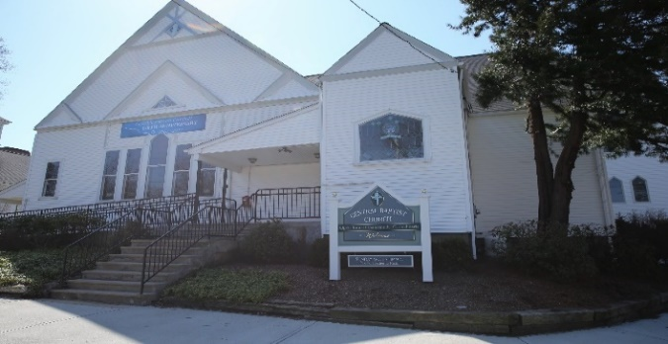

“Sometimes when our hearts break, they break open. And into that broken open space something enters that may not have entered otherwise—empathy, compassion, love, a form of courage and hope we didn’t know possible, a new beginning and eventually hallelujah.” – Carrie Newcomer

Welcome/Announcements

*Hymn In Christ There Is No East or West No. 285

Call to Worship
One: When the world is filled with controversy and conflict,

All: God calls us to discernment and reconciliation.

One: When our communities are troubled and in turmoil,

All: God calls us to overcome our apathy and act to bring change.

One: When our journeys are difficult and the way is uncertain,

All: God calls us to open ourselves to new possibilities as we worship together.

Unison Prayer of Invocation
O God, how good it is to join together in worship. Thank you that we don’t have to ask you to be present. We simply need to be aware of your presence—a gift for which we can truly be grateful. Help us to be aware of all your gifts—during this time of worship and throughout the coming week. We pray in the name of Jesus, who embodied your presence among us. Amen.

Gloria Patri No. 623
Glory be the Father and to the Son and to the Holy Ghost, as it was in the beginning, is now and ever shall be, world without end. Amen, Amen.

Anthem Let Us Sing Hallelu!
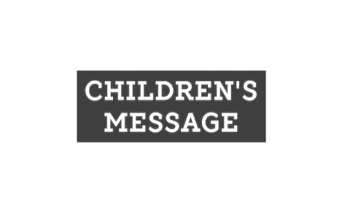
Sharing of Joys & Concerns

Pastoral Prayer & The Lord’s Prayer
Our Father, who art in heaven, hallowed be thy name. Thy kingdom come, Thy will be done, on earth as it is in heaven. Give us this day our daily bread. And forgive us our trespasses as we forgive those who trespass against us. And lead us not into temptation but deliver us from evil. For thine is the kingdom, and the power, and the glory, forever. Amen.

Offering & Offertory

Friendship Forms
Please pass the friendship pad in your pew to each person to sign. If you would like to be contacted by someone in the congregation, please leave a note with an e-mail or phone number.

*Doxology No. 625

*Prayer of Dedication (unison)

Scripture

Acts 11:1-18

Sermon An Attentive Congregation

*Hymn They’ll Know We Are Christians by Our Love No. 284

Benediction

Postlude

The Worship is ended…Our Service Now Begins

*Please stand if you are able

