**Central Baptist Church**

**Sunday, May 28, 2023**

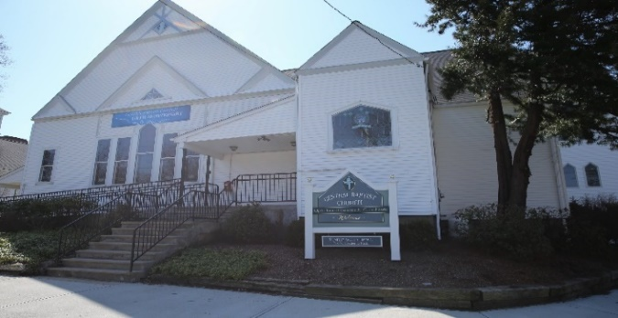

"The most powerful weapon on earth is the human soul on fire"

-- Ferdinand Foch

**Welcome/Announcements**

\***Hymn** *Spirit of God, Descend Upon My Heart* No. 249

**Call to Worship**

One: The Spirit descends like a dove,

All: Bringing peace and unity to the world, in a just and caring community.

One: The Spirit comes like breath

All: bringing life to renew the People of God

One: The Spirit spreads like fire

All: bringing energy for witnessing to the love of God

One: Spirit of the Living God,

All: come to us and transform our lives by your power!

**Unison Prayer of Invocation**

**We thank you, compassionate God, that you sent your spirit to encourage those whom Jesus left behind that they might not be alone.; Through the comfort of your presence, you empowered them to witness to your love.  Today, we also seek the encouragement of your presence.  Do not leave us alone, O God, but send your Spirit to us that we may worship and serve you with joy, through Jesus our crucified and risen Savior.  Amen.**

**Gloria Patri** No. 623

***Glory be the Father and to the Son and to the Holy Ghost, as it was in the beginning, is now and ever shall be, world without end. Amen, Amen.***

**Anthem** *Jehovah Jireh*

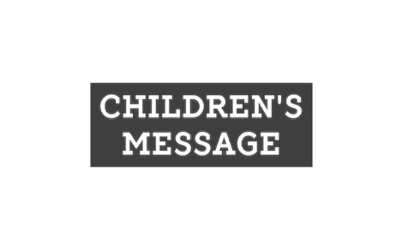

**Sharing of Joys & Concerns**

**Pastoral Prayer & The Lord’s Prayer**

***Our Father, who art in heaven, hallowed be thy name. Thy kingdom come, Thy will be done, on earth as it is in heaven. Give us this day our daily bread. And forgive us our trespasses as we forgive those who trespass against us. And lead us not into temptation but deliver us from evil. For thine is the kingdom, and the power, and the glory, forever. Amen.***

**Offering & Offertory**

**Friendship Forms**

Please pass the friendship pad in your pew to each person to sign. If you would like to be contacted by someone in the congregation, please leave a note with an e-mail or phone number.

\***Doxology** No. 625

\***Prayer of Dedication (unison)**

**Scripture**



***Acts 2:1-21***

**Sermon** *Tongues of Fire*

\***Hymn** *Battle Hymn of the Republic* No. 569

**Benediction**

**Postlude**

***The Worship is ended…Our Service Now Begins***

*Please stand if you are able