Central Baptist Church

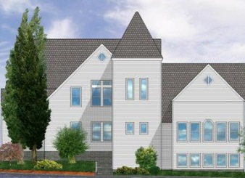
November 2018

CBC Courier

Pastor’s Pen
Let us come into his presence with thanksgiving, let us make a joyful noise to him with songs of praise! Psalm 95:2
Happy Thanksgiving to all,
Our national holiday of Thanksgiving has deep religious roots although some may assert it is a secular holiday. As a Christian community we recognize that each day is a time to offer thanksgiving to God for the abundant blessings of love our Lord imparts to all people.

In giving thanks we join the Psalmist in saying, let us make a joyful noise unto the Lord and come into His presence with thanksgiving. I encourage each of you to pray and offer thanks for God’s unfailing and unconditional love each day. Life is full of ‘busyness’ with our laundry lists of ‘things to do’ that never seem complete or finished. A wise use of our time leaves space for meaningful encounters with God. Another is setting aside ‘Sabbath time’ in worship or another space and time carved out in your week.

God allows us choices and it is my hope you choose your Sabbath time to be here at CBC. Each week we set aside time devoting ourselves to God’s Word, prayer, song, rest, renewal, companionship and fellowship. Worship is more complete with each of you present! I would love to hear from all our parishioners about sermon topics, favorite hymns and other facets of our service that inspire you or new ideas to stimulate our time together.

I offer my gratitude to God in serving a loving, friendly, caring community of believers that enhance my worship time at this beautiful and peaceful place we call our church home.

May you enjoy a blessed and enriching November and special time with family and friends for Thanksgiving.

In Christ’s love,
Pastor Kurt

Communion Sunday Collection
Running thru every Sunday during the month of November we will be collecting start- up funding for the CBC Food Pantry.

Little Dresses for Africa
The mission of “Little Dresses for Africa” is to provide relief to children of Africa, by distributing home-made dresses to little girls, primarily in African villages, but also other countries in crisis. These meetings will be on the 1st and 3rd Monday of the month from 1:00-3:00 p.m. in Clarke Hall. The meetings for November will be Nov. 5th & Nov. 19^{th.}

Ladies’ Breakfast
Ladies Breakfast will be held Thursday November 1st at 9 a.m. at Slice of Heaven.
All CBC ladies welcome!

CBC Walking Party
Please join us as we walk to up-beat music in Clarke Hall on Tuesdays and Thursdays from 8:00a.m. to approximately 8:45a.m. We do a warm-up, walk a couple miles, and do a cool down, then a few floor exercises to tone arms, legs, abs, chest and back. We are a fun bunch! Collectively, we’ve walked thousands of miles together! Please join us! Please contact Peggy Burse for questions.

Thanksgiving Baskets Collection
As the Rotary club donates turkeys and some trimmings for the Jamestown Thanksgiving baskets, we are going to work with St. Marks in filling the baskets with the extras. We will be collecting canned fruit, soups, cranberry sauce, and jellies.

Simple Blessings
"Simple Blessings: Centering Prayer and Discussion:" will be held Monday,
November 26th from 1:00 - 2:30 pm. in Clarke Hall. If anyone is interested there is a flyer and Sign-up sheet in church parlor or you can contact Janet Larson for questions.

Central Baptist Church Harvest Artisan Fair
CBC is hosting an Artisan Crafts Fair from 9 a.m. to 2 p.m. on Saturday, November 10^{th.} We have a small group of artist who have replied, we are certainly hoping for more. Please spread the word to any artists that you may know who’d like to be part of the crafts fair.

Calling all bakers…..
If anyone is interested in baking for the Harvest Artisan Fair
there will be a sign- up sheet in the church parlor. CBC will have their own table with baked goods. Peggy Burse will be the coordinator for the bake table. For questions, please contact Peggy at mrsburse@gmail.com or 423-3656.

Looking for the perfect gift?
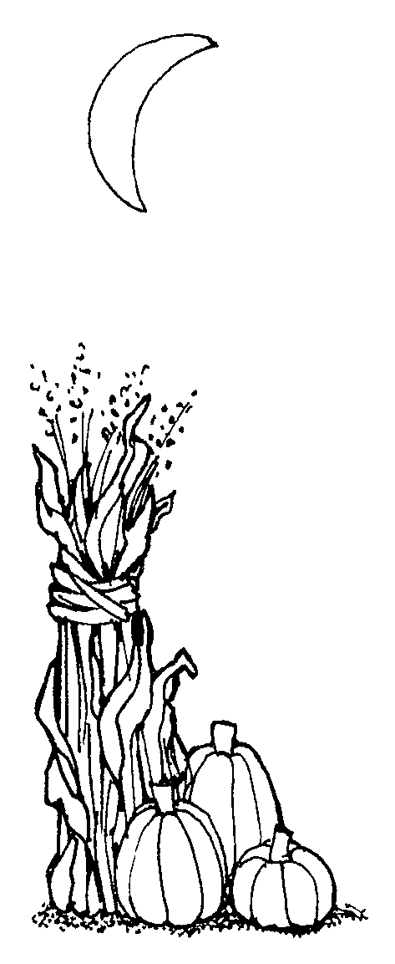

Please join us on
Saturday, November 10th
9 a.m. – 2 p.m.
For the
Harvest Artisan Fair
At
Central Baptist Church

99 Narragansett Avenue
Jamestown, RI 02835
401-423-1651

We Noticed Some Nice Things Happening at CBC

*** Thank you to Island Rubbish for disposing all of our
wood yard waste***

***Thank you to Atlantic Lawn & Garden for allowing CBC
to dump our yard waste at no cost!***

***Thank you to Alan Burse who is making a new advent
candle holder out of oak with a turned center post.***
***Thank you to the person/ persons who brought the Air
conditioners and fans up to the third floor***

***Thank you to Pam Carr who did the sign for the Looking
Upwards event we had last week***

*** Thank you to the person/ persons who painted the
closet in the back of the sanctuary.. It looks great!!!***

***Thank you to Rosemarie Smith, Deb Nordstrom and
Cara Popovich, who have taught Sunday School in
September and October***

***Thank you to all the Liturgist who helped Rev. Kurt for
September & October**

*** Thank you to everyone who has volunteered to make
coffee and goodies for our Sunday morning coffee
hour***

**If you see someone “doing something nice for CBC or to thank someone". Please call the church office 423-1651 or by e-mail to tanya@cbcjamestown.com your input is always appreciated…Thanks!!**

Adopt a Family
CBC will be doing the Adopt- a Family program again this year!!
More specific information on the families we get will be available on or around Sunday, November 11th. There will be a sign-up sheet available for these families in Clarke Hall.

Wreath Making Greens
We are in need of berries and greens bushes, such as white pine, cedar, cedar with the blue berries, boxwood, juniper, winterberry or any other type of greens that could be used to make the Christmas wreaths. Please contact Jill Dolce 842-9661 or Dave Dolce 374-2858.

Christmas Wreath Decorating
We are looking for volunteers to help make wreaths on November 25th at 11:00 a.m. in Fellowship Hall (basement). Supplies will be on hand, but if you have sheers to cut greens, please bring them. If you have any questions, please contact Jill or Dave Dolce.

Christmas Fair
Saturday, December 1 9:00 a.m.-1:30 p.m.
As our annual Christmas Fair draws closer, here are some ways you may lend a hand:

Gift Baskets
Sign up to donate items for a theme gift basket. Baskets and their contents will be due on Sunday, November 18.

Baked Goodies
Sign up to bake goods for our bake table. A sign-up sheet will be available in the church parlor.

Silent Auction
Donate a service (i.e., babysitting, tutoring, cooking) for the fair’s silent auction. Gift cards/certificates and items such as jewelry, pieces of art, and collectibles also are welcome contributions for the auction.

Christmas Items
Donate holiday items—ornaments, candles, decorations, etc.—for the fair’s Christmas table. A basket is available in the church parlor.

Fair Volunteers
Plan to work during the fair. We will need as many volunteers as possible--especially volunteers who are able to arrive in time to set up, work throughout the fair, and help with cleanup. We also will need volunteers to help during the week of the fair.

Poinsettia Orders
Orders for Christmas poinsettias for our sanctuary are being accepted. The plants will be available in red, white, and pink for $16.50 each. You may designate the poinsettia(s) you order in memory or honor of a person or event. The deadline for orders is Sunday, December 16. Order forms are available in the church parlor or from the church office.

-------------------------------------------------------------------------------------------------------------------------
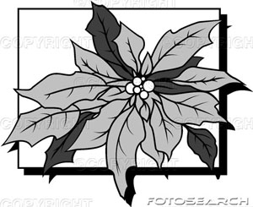

Poinsettia Order Form

Name(s) _____________________________________ Phone ____________________

The poinsettias will be provided by The Secret Garden. They will be available in red, white, and pink and will cost $16.50 per plant. Please make checks payable to Central Baptist Church. (Payment must be included with this order form.)

Include in the Christmas insert as:

(Choose one) ___ In memory of or ___ In honor of

________________________________________________________

Given by ________________________________________________________

Color ___ Red ___ White ___ Pink ___ Would like to keep

The deadline for ordering poinsettias is Sunday, December 16.
Please place your order form and payment in the box in the parlor, or mail them to the church office at P.O. Box 295, Jamestown, RI 02835-0295.

___________________________________________________________

Central Baptist Church
A church with open doors A congregation with open minds A community with open hearts
99 Narragansett Avenue
(Mail: P.O. Box 295)
Jamestown, RI 02835
(401) 423-1651
cbc@cbcjamestown.com
www.cbcjamestown.com

Pastor Administrative Assistant Organist Custodians
Kurt Satherlie Tanya Crowley Walter Sage John & Jim Page

