Central Baptist Church

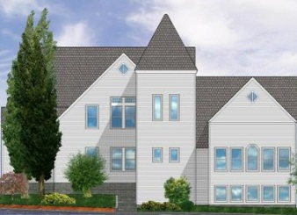
November 2017

CBC Courier

Pastor’s Pen
Rejoice always; pray without ceasing; in everything give thanks; for this is God’s will for you in Christ Jesus ~1 Thessalonians 5:16-18

Dear Church Family,
With few remaining leaves left to fall from the trees we turn our hearts to Thanksgiving, in a new land, new neighbors, new friends, the first celebration dates back to November 1621 with Pilgrims arriving from England joining Native American Wampanoag’s to gather for an autumn harvest celebration. The newly arriving Pilgrims were embraced not only by a feast but grateful for what we could consider being the first New World ‘community’ gathering.

CBC’s vision and mission are focused on community and thankfulness to God very much like the first Thanksgiving ~ as our forefathers and foremothers offered thanks to God with new opportunities: religious freedom, harmony with neighbors, and gratitude to the Creator. Embrace the opportunity to offer our own gratitude to God for each new day with the freedom to worship as we choose, to enjoy fellowship and welcoming others as we give daily thanks to the Maker of all Life.

May you and I spend time in God’s creation of beauty; the peace of the endless blue sea and sky, the wonder of the everlasting hills, and the mystery of all life. Soak and bask in Christ’s tranquility and serenity remembering His words:
“Peace I leave with you; my peace I give you. I do not give to you as the world gives. Do not let your hearts be troubled and do not be afraid.” John 14:27

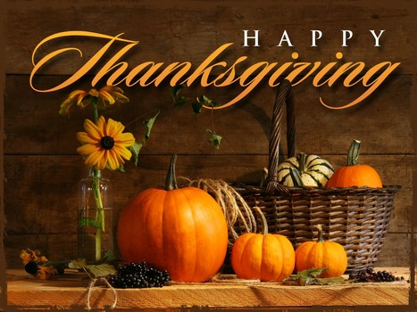
In Christ’s love,
Pastor Kurt

Communion Sunday Collection
Next Sunday running thru the month of November, we will be collecting women’s hygiene items, diapers and wipes. We will be donating all the items to Lucy’s Hearth in Middletown.

Ladies’ Breakfast
Ladies Breakfast will be held Thursday October 12th at 9 a.m. at Slice of Heaven. All CBC ladies welcome!

CBC Players Present: "Our Town"
Don't miss CBC Players' presentation of Our Town, Thornton Wilder's classic play about small-town life. The production is part of the church's 150th Anniversary Celebration.
Performances at CBC will be as follows:
Friday, November 3 @7:00 p.m.
Saturday, November 4 @ 7:00 p.m.
Sunday, November 5 @ 4:00 p.m.
Tickets will be available for purchase at:
The Secret Garden, Baker’s Pharmacy, Yes! Gallery and Pleasant Surprise. $12 Adults, $10 Seniors & Students and $14/ $12 at the door.

Conspire 2017: Transformation
Join us at CBC on Monday's 9:30-11 a.m. November 6th -December 18th to view and discuss the presentations from the Conspire 2017 conference. The theme of this year's conference is TRASNFORMATION: The separate self is the major problem, not the shadow self, which only takes deeper. forms of disguise. The shadow self can be defines as those negative aspects of ourselves, which we deny and /or defend. The separate self does not recognize the divine nature present in all beings and makes choices focused on personal gain and desires and not the greater good.

Adopt a Family
This Christmas season for our Adopt a Family:
We have a family of three, a mom and two girls, who are middle school age.
Two senior women. And finally a young man in the military, who is being deployed.
More specific information will be available on or around November 12th There will be a sign-up sheet available for these families in Clarke Hall.
The deadline will be Sunday, December 10.

CBC’s 150th Anniversary Dinner
Following the gala event of “Our Town” we will continue to celebrate with our 150th Anniversary Dinner which will be held at the Conanicut Yacht Club on November 11th. The doors will open at 6 p.m. and dinner is at 7 p.m. Tickets are $35 per person. All of our CBC congregants are invited as well as past ministers, CBC members and family and friends. If anyone needs financial help with purchasing a ticket, please contact Pastor Kurt.

Warm Coats, Warm Hearts Coat Drive
November 18th 10 a.m.-2 p.m.
If anyone is interested in collecting coats, scarves, mittens/gloves and hats for members of our community. You can drop them off at CBC on Monday – Thursday between 9 a.m. to noon prior to the morning of the coat drive. Please use the side door (church office). Our mission at CBC is to help anyone who is in need to have a warm winter. Please contact Jean Britton 423-0470 for questions.

Little Dresses for Africa
The mission of “Little Dresses for Africa” is to provide relief to children of Africa, by distributing home-made dresses to little girls, primarily in African villages, but also other countries in crisis. These meetings will be on the 1st and 3rd Monday of the month from 1:00-3:00 p.m. in Clarke Hall.

Living with Conscious Abandon
Will meet on the 4th Monday of each month at CBC in Clarke Hall from 1 - 2:30 pm. The group focuses on personal reflection of both Christian and Eastern Spiritual guidelines in living each day with conscious awareness of personal intention, thought, speech and actions. Join us as we gather to share our responses to daily reflections that will support us in living our lives with wisdom, integrity and compassion. Our reference guide is Living and Dying with Confidence: A day by day guide by Anyen Rinpoche and Allison Choying Zangmo. The text may be purchased at Amazon for $11.We will begin with month 5 in October. All are welcome. The class is free of charge. Rev. Kurt Satherlie and Janet Larson facilitate the sessions. Mark your calendar for this seasons' sessions: Oct. 23, Nov. 27, Dec. TBA, Jan 22, Feb. 26, Mar. 26, Apr. 23, May TBA.

Wreath Making Greens
We are in need of berries and greens bushes, such as white pine, cedar, cedar with the blue berries, boxwood, juniper, winterberry or any other type of greens that could be used to make the Christmas wreaths. Please contact Jill Dolce 842-9661 or Dave Dolce 374-2858.

Christmas Wreath Decorating
We are looking for volunteers to help make wreaths on November 26th at 11:00 a.m. in Fellowship Hall (basement). Supplies will be on hand, but if you have sheers to cut greens, please bring them. If you have any questions, please contact Jill or Dave Dolce.
Christmas Fair
Saturday, December 3 9:00 a.m.-1:30 p.m.
As our annual Christmas Fair draws closer, here are some ways you may lend a hand:

Gift Baskets
Sign up to donate items for a theme gift basket. Baskets and their contents will be due on Sunday, November 20.

Baked Goodies
Sign up to bake goods for our bake table. A sign-up sheet will be available in the church parlor.

Silent Auction
Donate a service (i.e., babysitting, tutoring, cooking) for the fair’s silent auction. Gift cards/certificates and items such as jewelry, pieces of art, and collectibles also are welcome contributions for the auction.

Christmas Items
Donate holiday items—ornaments, candles, decorations, etc.—for the fair’s Christmas table. A basket is available in the church parlor.

Fair Volunteers
Plan to work during the fair. We will need as many volunteers as possible--especially volunteers who are able to arrive in time to set up, work throughout the fair, and help with cleanup. We also will need volunteers to help during the week of the fair.

Poinsettia Orders
Orders for Christmas poinsettias for our sanctuary are being accepted. The plants will be available in red, white, and pink for $16 each. You may designate the poinsettia(s) you order in memory or honor of a person or event. The deadline for orders is Sunday, December 10. Order forms are available in the church parlor or from the church office.
Prayer Chain
Would you like to be part of CBC’s prayer chain—a group of people who pray for various needs in and outside our church family? If so, please speak with Joanne Hulme at 423-2368

CBC Walking Party
Please join us music in Clarke Hall on Tuesdays and Thursdays from 8:00a.m. to 8:45a.m.We do a warm-up, walk a couple miles, do a cool down, then a few floor exercises. Please join us! Questions? Contact MariBeth Traer.

-------------------------------------------------------------------------------------------------------------------------
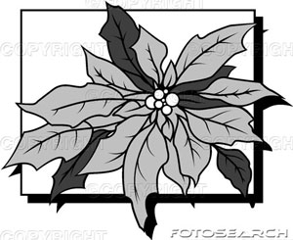

Poinsettia Order Form

Name(s) _____________________________________ Phone ____________________

The poinsettias will be provided by The Secret Garden. They will be available in red, white, and pink and will cost $16 per plant. Please make checks payable to Central Baptist Church. (Payment must be included with this order form.)

Include in the Christmas insert as:

(Choose one) ___ In memory of or ___ In honor of

________________________________________________________

Given by ________________________________________________________

Color ___ Red ___ White ___ Pink

The deadline for ordering poinsettias is Sunday, December 10.
Please place your order form and payment in the box in the parlor, or mail them to the church office at P.O. Box 295, Jamestown, RI 02835-0295.

____________________________________________________________

Central Baptist Church
A church with open doors A congregation with open minds A community with open hearts
99 Narragansett Avenue
(Mail: P.O. Box 295)
Jamestown, RI 02835
(401) 423-1651
cbc@cbcjamestown.com
www.cbcjamestown.com

Pastor Administrative Assistant Custodians
Kurt Satherlie Tanya Crowley John & Jim Page

