Central Baptist Church

October 2017

CBC Courier

Pastor’s Pen

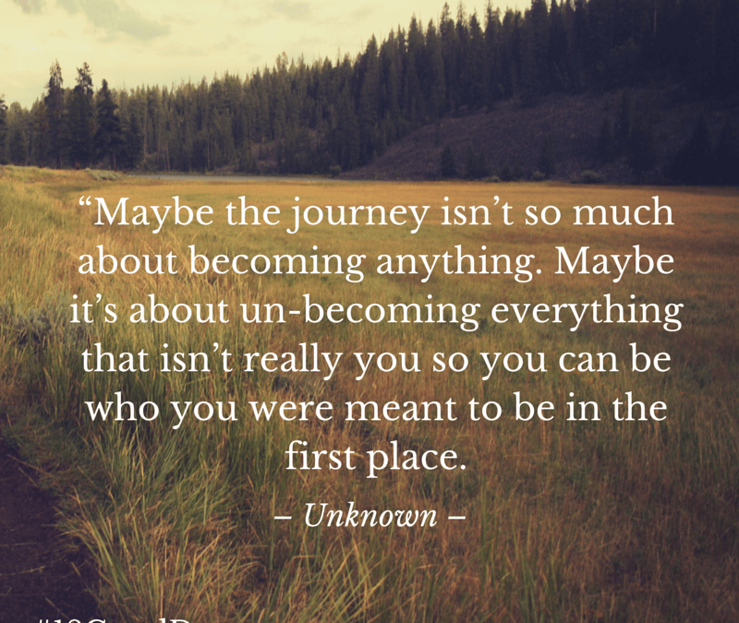

Dear CBC Family~

October is my favorite month of the year. I love the change of seasons, the crisp fresh air, the colors, and the wonderful fragrances in the air. For some, it’s all about having fun on Halloween. Halloween is a special time for our young and not so young yet does not excite me other than the trick or treaters who come to our door. Dressing up in costumes for a party, decorating the house or carving pumpkins is fun yet what happens when the masks we wear cover just another mask we may not remove from the publics eyes. I am speaking about the masks that do not scare others yet without them, may tend to frighten us. I refer to the emotional masks that we hide behind because of fear that someone may be able to see the true person we are. And the fears are more than not, erroneous and inaccurate.

Like a Boxer, we are adept at keeping our guard up thinking if the world knew how we really felt or thought, they would be disappointed at the least or disgusted at worst. The masks we wear become walls that either keep out or not allow someone in. Our thinking is unfounded on most levels yet we all fall prey to wearing masks at times or all the time.

Creative costumes and masks to hide our identity at a party is a lot of fun and enjoyable for our youth as well as all ages. Yet as we go through life, do we shy away from who we truly are, the creation of the Great Creator who does not make mistakes. Others witness or perceive us through the masks we wear and it’s not always a mystery as to why we try to ‘cover-up’ who we really are. The mask we wear often disguises who we truly are inside and protect ourselves from being tainted and by the harsh judgment of others or how we may perceive how others would react if they knew the ‘real’ person behind the facade!

The mask we wear in our everyday lives disguises much more than the face underneath it. It hides who we truly are inside and protects our soul from being ridiculed and torn in shreds by biases, preconceptions, and narrow-mindedness of others.

We were not meant to mask ourselves before our fellow-beings, but to be, through our human forms, true and clear utterances of the spirit within. Since God gave us these bodies, they must have been given us as guides to Him and revealers of Him. ~Lucy Larcom, American author, and poet.

Like most people, I want to be liked by everyone. Many of us are similar yet at what cost? Do you sacrifice your own happiness to make others happy? Is there such a person who does not have imperfections other than Christ? The happier you are with yourself the more you can be ‘present’ for others who in turn will prosper from the genuineness they witness. Make this October a Halloween to remove our masks and let people see the beauty that lies beneath it.

In Christ’s love,
Pastor Kurt
Communion Sunday Collection
Running thru every Sunday during the month of October we will be collecting grocery items to donate to the Jamestown Food Bank.

Ladies’ Breakfast
Ladies Breakfast will be held Thursday October 12th at 9 a.m. at Slice of Heaven. All CBC ladies welcome!

CBC Grounds Keep Day
We will have a fall outside cleanup day on Saturday, Oct. 21 at 9 am. Please see Jill Dolce for any questions.
Also, we would like to start a CBC Garden Group, this group would be to keep up with the weeding throughout the year. Any interest in participating in this group, contact Jill.

Children and Youth Fall Harvest Party-
Bring a friend and join us Friday, October 27th from 5:45-8:00pm for some fun Fall activities, games and refreshments. Fun will include: pumpkin carving, bobbing for donuts, make your own gourmet caramel apples, pumpkin bowling, mummy wrapping, pumpkin seed spitting contest (eww!) and more! Please RSVP to Cara in person, email cpschool07@gmail.com, or phone/ text 575-2304.

Little Dresses for Africa
The mission of “Little Dresses for Africa” is to provide relief to children of Africa, by distributing home-made dresses to little girls, primarily in African villages, but also other countries in crisis. These meetings will be on the 1st and 3rd Monday of the month from 1:00-3:00 p.m. in Clarke Hall.

Living with Conscious Abandon
Will meet on the 4th Monday of each month at CBC in Clarke Hall from 1 - 2:30 pm. The group focuses on personal reflection of both Christian and Eastern Spiritual guidelines in living each day with conscious awareness of personal intention, thought, speech and actions. Join us as we gather to share our responses to daily reflections that will support us in living our lives with wisdom, integrity and compassion. Our reference guide is Living and Dying with Confidence: A day by day guide by Anyen Rinpoche and Allison Choying Zangmo. The text may be purchased at Amazon for $11.We will begin with month 5 in October. All are welcome. The class is free of charge. Rev. Kurt Satherlie and Janet Larson facilitate the sessions. Mark your calendar for this seasons' sessions: Oct. 23, Nov. 27, Dec. TBA, Jan 22, Feb. 26, Mar. 26, Apr. 23, May TBA.

CBC Players: "Our Town"
Baked Goods
We will be selling baked goods during intermission of each performance. Sign-up sheets will be in church parlor for bakers or you can call Ellen Greene at 423-2261.

“Our Town” Tickets
Tickets will be available for purchase at:
The Secret Garden / Jamestown
Baker’s Pharmacy/ Jamestown
CBC/ Jamestown
Yes! Gallery/ Wickford
Pleasant Surprise/ Newport

Prayer Chain
Would you like to be part of CBC’s prayer chain—a group of people who pray for various needs in and outside our church family? If so, please speak with Joanne Hulme at 423-2368

CBC Walking Party
Please join us music in Clarke Hall on Tuesdays and Thursdays from 8:00a.m. to 8:45a.m.We do a warm-up, walk a couple miles, do a cool down, then a few floor exercises. Please join us! Questions? Contact MariBeth Traer.

____________________________________________________________

Central Baptist Church
A church with open doors A congregation with open minds A community with open hearts
99 Narragansett Avenue
(Mail: P.O. Box 295)
Jamestown, RI 02835
(401) 423-1651
cbc@cbcjamestown.com
www.cbcjamestown.com

Pastor Administrative Assistant Custodians
Kurt Satherlie Tanya Crowley John & Jim Page

